Title of the scientific contribution
N. Participants¹, N. Author^{2,3}, N. Author³ and L. Author³
- Participant’s affiliation , Department, ZIP – City
- Affiliation, Department, ZIP – City
- Last affiliation, Department, ZIP – City
The abstract should be written in English and cannot exceed one page (fit in this frame). For the title use Character Type Times New Roman 14; authors’ name 8 and affiliation 7,5pt. In the authors’ list the name of the presenting author should be underlined. Text should be full justified, 1.2 leading, Times New Roman 9. Do not leave blank lines between paragraphs. References should be numbered consecutively and placed in the text as superscript arabical numeral surrounded by square brackets.^{[1]}
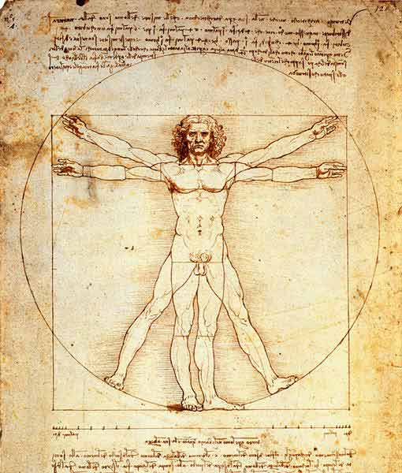
Use the “REFERENCES” (Times New Roman, 7,5pt single spaced, left aligned) syntax to write the bibliography.
Figure 1. Figure caption example
The abstract may contain tables and or figures. Figures will be printed in gray scale. Please, do not cite the figures in the text, but use captions to the figures. Figures should be centred without surrounding text. The captions should be centred with character size 7.
The best way to implement these rules is to write inside this document without using the “paste” function to cut and paste from another file. Please use the WORD function “paste special” to paste the text in unformatted way.

References
- P. Scott, V. Adels J. Appl. Crystallogr. (2007), 35, 24.
- P. Scott, V. Adels J. Appl. Crystallogr. (2007), 35, 24.

